Shabbos Stories for
chanukah 5783
Volume 14, Issue 15 – 25 Kislev – 2 Teves 5783/December 19-26, 2022
Printed L’illuy nishmas Nechama bas R’ Noach, a”h

For a free subscription, please forward your request to keren18@juno.com

Story #1150
The Visible Light
Of the Menorah
From the desk of Yerachmiel Tilles
editor@ascentofsafed.com

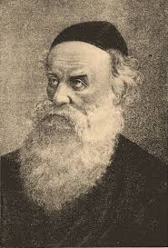
The Alter Rebbe

The bitter conflict between Napoleon and Russia had been raging for months. Civilian travel within Russia was treacherous for all, but especially for Jews, for whom such journeys were fraught with danger even in the most tranquil of times. But what can one do if his livelihood depends on traveling from region to region, from city to city? The merchant [whom we shall call] Menashe, with a family to feed, had little choice but to accept the risks of his trade - war or no war.
He undertook these business trips each year soon after the High Holidays, making his way from his shtetl to the distant, unwelcoming regions of Russia beyond. The success of these ventures often depended upon personal connections and sheer guile. Indeed, despite the edicts of the Czar, Menashe had, at times, even sneaked into cities where Jews were denied entry.

An Especially Perilous Journey
This year, he knew, his journey would be especially perilous. Before taking to the road, he fortified himself by receiving a blessing for success from his rebbe, (the Alter Rebbe - Rabbi Schneur Zalman of Liadi.
On the day of his departure, he bade farewell to his wife with more anxiety than usual.
Every few days, by mail or word of mouth, Menashe's wife received notice from her husband, informing her of his whereabouts and activities. She was delighted when a letter arrived from Petersburg, dated the second day of Chanukah, informing her that his business dealings had gone well and with G-d's help, he'd be returning home soon.
The she heard nothing more.
Days passed, then weeks, and still not a word. Her small children stared out the window, awaiting the gifts their father always brought when he returned from his far-away travels. But there was no sign of Menashe. No posts, no regards, no reports of chance encounters. Months passed. It was as though he had disappeared into thin air.

Officials in Petersburg Had More Issues
Than to Worry About a Missing Jew
Had these been normal times, a few Jewish community activists would have traveled to Petersburg to make inquiries, but with the country at war, such a venture would be useless. Officials in Petersburg, a Czarist capital city, had more pressing issues to contend with than missing Jews. As for Menashe's wife, she sent urgent letters to every agency that might prove helpful, but received replies from none. Not knowing where to turn next, she sought the advice of the Rebbe.
"I am a veritable agunah" [an abandoned but still legally married woman, since it is unknown whether her husband is currently alive or not], she told the rebbe. "As for my children, they're suffering as though they are orphans."
The rebbe consoled the woman and assured her that, with G-d's help, her husband would return home safely.
Spring passed, then summer and autumn too, and soon the winter winds were already announcing their presence. The war continued to rage, the Russian forces losing one battle after the next. These were days of great travail for the entire population and, as usual, especially for Jews.
Still, a man must earn a living. The previous year, it was Menashe who had traveled through the embattled region; this year, Tzvi-Hirsch [as we shall call him] would face the same challenge. Like Menashe, Tzvi Hirsch was a devoted chasid of the first Chabad-Lubavitcher Rebbe, and therefore sought the tzadik's blessing before commencing his trip.

A Special Request from His Rebbe
As Tzvi Hirsch prepared to leave the room after receiving the desired blessing, he heard the rebbe calling to him.
"Tzvi Hirsch, you said you'd be gone for several months, yes? That you expect to be away during Chanukah?"
"Yes, I'll still be on the road," Tzvi Hirsch replied.
As in years past, he'd planned his itinerary so he could celebrate Chanukah in a town inhabited by Jews and, if possible, with other chasidim. But why was the rebbe asking about this now?
"I want to remind you," the rebbe continued, "an essential requirement of the mitzvah of lighting the menorah is pirsumei nisa, the public proclamation of the Chanukah miracle. That is why the Talmud instructs us to put our menorah outside the front door [1] opposite the mezuzah or next to a window facing a public area so its light will be visible to the world."
"Yes, of course," Tzvi Hirsch said. "I always place my menorah near the window in my house."
"Good," said the rebbe. "But remember, the performance of pirsumei nisa isn't limited to one's own home. One must ensure the menorah is visible in whatever location one finds oneself. May you have a safe, successful trip."

A Heavy Snowfall Rendere the Main Roads Impassable
Tzvi Hirsch was a considerably more successful merchant than Menashe, for whom every ruble was a struggle. Tzvi Hirsch's formidable connections allowed him to walk through doors closed to other Jews and to sojourn in royal cities like Petersburg, from which Jews were officially barred. But this was wartime, and all the thoroughfares were controlled by hostile military personnel. Meanwhile, a heavy snow had blanketed the roads, rendering the main arteries impassable.
On the eve of the first night of Chanukah, Tzvi Hirsch found himself stranded in a forsaken, isolated village, where he doubted even one Jew could be found. Given the weather conditions, he had no choice but to resign himself to spending the coming days at the local inn.
Alone in his room, Reb Tzvi Hirsch welcomed the holiday of Chanukah, reciting the traditional liturgy that recalls the miracles of the past and expresses the hope that they will recur in our own day. At the end of prayers, he removed a menorah from his bag, and prepared to place it on a chair across from the mezuzah affixed to a doorpost, forgetting for a moment he'd find no mezuzah in this gentile inn. Casting about for an appropriate spot, he suddenly remembered the rebbe's exhortation to light the Chanukah menorah in public view.

Lit the Menorah with All the Zeal He Could Muster
And so, Tzvi Hirsch dutifully set up his menorah near the window of his shabby room. Who would see the modest flames of these wicks'? The storm had intensified during the past few hours; no one in his right mind would dare extend a finger into the howling wind, let alone hazard a walk outside.
Nevertheless, Tzvi Hirsh set aside his puzzlement and kindled the menorah with all the zeal he could muster. A surge of homesickness overwhelmed him as he thought about the joyful Chanukah celebrations at the court of his rebbe. Fighting pangs of loneliness, he pulled a chair up next to the menorah, and began singing a chasidic melody.
The second night of Chanukah was no different. Tzvi Hirsch lit the two wicks in front of the window as an unrelenting gale lashed against the pane. Once more, he sat across from his menorah and immersed himself in Chassidic song and prayer. So absorbed was he in his devotions that he failed to notice the door open, or the man who'd quietly entered his room.

The Military Officer Stared Silently
At the Jew Celebrating Chanukah
The unobserved visitor was immaculately dressed in a military officer's outfit, his jacket bedecked with medals. He stared silently at the Jew swaying slowly in his chair, oblivious to his surroundings.
When Tzvi Hirsch finally opened his eyes, he lurched from his seat, and quickly removed his cap in reflexive obeisance. But the officer merely smiled, and readily accepted Tzvi Hirsch's invitation to have a seat.
"Allow me to explain my presence here," the officer said. "I came to this province on military leave. I'm staying in a room nearby. Last night I noticed a peculiar light coming from your room. A mere flicker, hardly enough to yield warmth or even light. I thought, How strange! And when tonight, I saw two such glimmers from this room, I asked myself, What is going on in there? I knocked on the door and receiving no reply, let myself in. And what do I see? A Jew busying himself with a small lamp. And so, I ask myself, What is a Jew doing in this remote part of the country? And what is he doing with this little lamp of his?"
"I will explain," said Tzvi Hirsch, speaking in fluent, sophisticated Russian. He recounted the history of the holiday, the Maccabees' valiant battle for freedom, the ritual lighting of the candelabrum, one additional light each night, progressing to eight, in commemoration of the discovery of a small flask of pure oil that miraculously burned in the destroyed Temple for eight days.

Stunned by the Realization of Another Jew’s Innocent
"So, the Jew is innocent after all!"
"What Jew?" asked Tzvi Hirsch. "Innocent of what?"
"He did tell us the truth."
"Sir, what Jew? The truth about what?"
The officer leaned back in his chair. "I am a military judge in the military court in Petersburg," he said. "Last year -around this time, in fact - we were presented with a Jew arrested as a spy. His name was Menashe, as I recall. The evidence pointing to his guilt was substantial. For one thing, he was found in Petersburg, where Jews are not permitted entry. For another, he was carrying false papers. And then there was this business of the lights. He was kindling his lamp near a window, one night one candle, two on the nest night and so on. We concluded this was a signal to the enemy, a code communicating the number of battalions arriving in the city.
"The Jew admitted that he was in the city illegally, but insisted that he was there only to conduct some business and certainly not to spy. What about the lamp, the lights in the window? He said this was a ritual belonging to the Jewish holiday of Chanukah.
"He didn't convince the court, although that may have been because, to tell the truth, we weren't inclined to believe his account. The man was sentenced to a ten-year prison term."

The Officer’s Promise to Correct His Mistake
"What happens now?" Tzvi Hirsch asked, astonished.
"Well," said the officer, "I see now we should have listened more judiciously to what the Jew had to say. As soon as I return from my furlough, I'll see to it that he is given his freedom."
When Tzvi Hirsch returned to his town, he was greeted by the news that Menashe was already in his own home, reunited with his family. Not even Menashe knew what had prompted his sudden release, although he and his family were exuberantly grateful when they found out.
As for Tzvi Hirsch, each year when he lit his menorah, he made sure not only to proclaim the miracle of Chanukah that had occurred two millennia earlier, but also the miracle that occurred in his own day.
~~~~~~~~~~~~
Footnote:
[1]Because of the possible danger involved from anti-Jews, the custom in many countries has become to instead light opposite the mezuzah of an interior doorway (see further in the story), in the presence of family members and/or others.
Source: Edited and supplemented by Yerachmiel Tilles from the book "The Blind Angel" by Tovia Halberstam, as translated from the Hebrew and lyrically retold by [his son] Joshua Halberstam.
Biographical note: Rabbi Shneur Zalman [of blessed memory: 18 Elul 5505 - 24 Tevet 5573 (1745 - Dec. 1812 C.E.)], one of the main disciples of the Maggid of Mezritch, successor to the Baal Shem Tov. He is the founder of the Chabad-Chassidic movement and the author of Shulchan Aruch HaRav and Tanya as well as many other major works in both Jewish law and the mystical teachings.

Reprinted from the Chanukah 5780 (2019) email of KabbalaOnline.org, a project of Ascent of Safed.

Illuminating a Dangerous Night During the Crusades
By Rabbi Dovid Hoffman

The following story is said to have taken place during the 1200’s. The Second Crusade was under way. Thousands of peasants became soldiers overnight and marched across Europe to fight the Muslims who had conquered the Holy Land. It was an adventure for them, and their religious leaders promised them great rewards if they were successful.
So, the ignorant peasants banded together and marched - and the first thing they did was massacre the Jews wherever they went. The ancient community of Eisenstadt, Germany, was a proud and vibrant kehillah; yet they now lay directly in the path of the marauding crusaders.
The Jews, terrified and frantic, ran to their rabbi for advice. Calmly, the rabbi replied, “It is late in the afternoon. Let us assemble in the shul for Mincha/ Maariv prayers. As Hashem wishes, so shall be our fate.”
Swiftly the men, women and children came to the shul. The davening that afternoon was unlike any other. Every word was said slowly, clearly, tearfully, from the worshipers who were facing massacre and death, the children did not know what was happening, but the fright and terror of their parents spread to their hearts.
The shammas bolted and barricaded the heavy doors. There was no need to leave the doors open any more. Every Jew in Eisenstadt was inside that shul. It was the first night of Chanukah. Whatever will happen, the first candle must be lit! The rabbi motioned to the shammas, who nodded and brought a box of candles. Then the rabbi walked toward the menorah that always stood on a shelf on the south wall - but it was gone!
What had happened to it? But there was no time to think about that now. The mob would be here at any moment. Men, women and children cried and wailed. The rabbi went up before the Ark and asked for silence. The trembling assembled looked up, wondering what the rabbi would say in these, their final moments.
“Tonight,” the rabbi began, “is the beginning of Chanukah. At this time many years ago, our forefathers were saved from a terrible fate. Tonight, we cannot celebrate this holiday, because our menorah is lost. But if we are worthy, another Chanukah miracle can happen tonight. Even when the sword lies on the throat of a Jew, he does not give up hope. We are Hashem’s children so we must not give up hope. Until the last moment let us pray; and if that moment should come, let us know and understand that it is the will of the Holy One, Blessed is He. Let us meet our death as loyal Jews!”

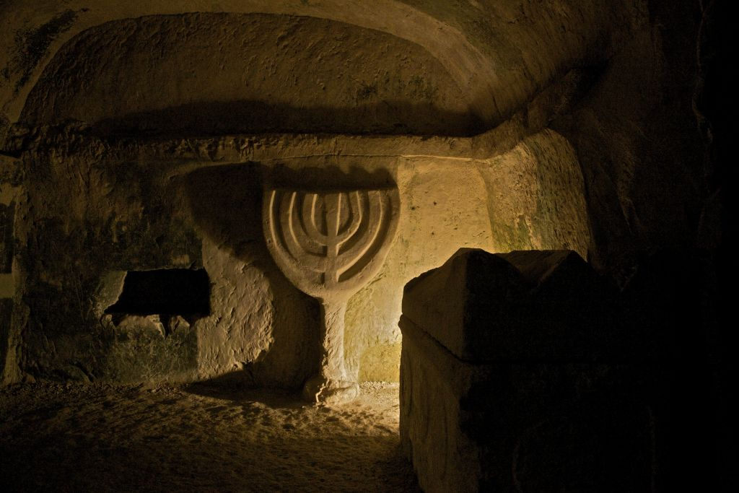

Everyone remained silent. Then the shammas suddenly cried out, “Now, I remember!” Everyone looked at him, startled. He went on, “There is another menorah in the Aron. I know I saw it, but I couldn’t remember where.”
He opened the Aron and reached down into the left-hand corner. His hand grasped the menorah and pulled. The menorah wouldn’t budge. It stuck fast. He tried to turn it. And strangely, it turned freely. He looked down and couldn’t believe his eyes.
The platform in front of the Aron, on which he was standing, was moving inward. Below was a stone staircase. Like an electric shock the news spread through the crowd. The rabbi and the shammas began directing everyone down the stairs, and as each one went down, he took with him one of the Sifrei Torah from the Aron.

After the Last Person Safely Descended Down the Staircase
When the last person had descended, the rabbi calmly shut the doors of the Aron, went down the stairs, and pulled the platform board to its regular position. As he did so, the shul doors crashed and splintered. While the mob let their wrath out on the empty seats, the Jews walked along an underground tunnel until they reached a large chamber, with ladders all around leading to trap doors.
But before the people could rest, the rabbi said, “In peril we turned to our Creator; now we must thank Him. Let us say Hallel.” In that underground room cut out in the earth, they all recited Hallel with great fervour.
Afterwards, the rabbi made two indentations in the chamber’s wall with his fingers. In each he stuck a candle, and lit the top one. With tears in his eyes, he chanted the blessings for the Chanukah candles and then lit the other candle. While the menorah burned brightly, lighting up the dim chamber, no one spoke. They just gazed at the candles and seemed to absorb what it was saying - the message of Chanukah - the promise of rescue to those who deserve it.

Reprinted from the archives of Torah Tavlin.

